PyDev Tutorial
Installing with the zip file
The available locations for the zip files are:
- SourceForge download
After downloading the zip file:
Extract the contents of the zip file in the eclipse/dropins folder and restart Eclipse.
If it doesn't work, try restarting Eclipse with the -clean flag (if you're a regular user and installing with admin, make sure you call -clean logged in as admin, so that Eclipse finds out about it).
If it's still not found, double check the requisites (such as the Java vm version).

Checking the installation
You can verify if it is correctly installed going to the menu 'window > preferences' and checking if there is a PyDev item under that.

Configure Interpreter
After installing it, the first thing you must do is configure the Python and/or Jython and/or IronPython interpreter.
To configure the interpreter:
1. Go to: window > preferences > PyDev > Interpreter - (Python/Jython/IronPython).
2. Choose the interpreter you have installed in your computer (such as python.exe, jython.jar or ipy.exe).
Note that the Auto Config will try to find it in your PATH, but it can fail if it's not there (or if you want to configure a different interpreter).
On Windows it'll also search the registry and provide a choice based on the multiple interpreters available in your computer (searching in the registry).
On Linux/Mac, usually you can do a 'which python' to know where the python executable is located.
On Mac it's usually at some place resembling the image below (so, if you want to configure a different version of the interpreter manually, that's where you'd want to search):
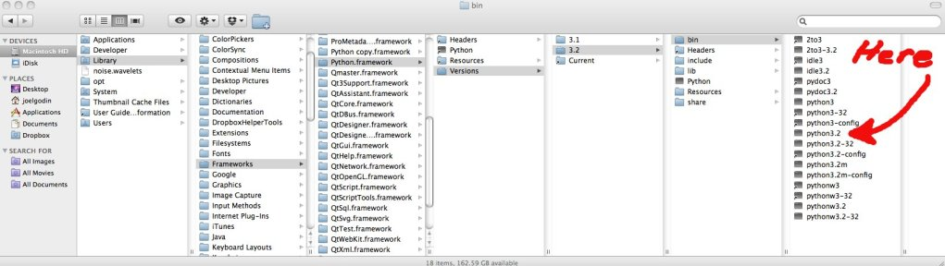
3. Select the paths that will be in your SYSTEM PYTHONPATH.
IMPORTANT: Select only folders that will NOT be used as source folders for any project of yours (those should be later configured as source folders in the project).
IMPORTANT for Mac users: The Python version that usually ships with Mac doesn't seem to have the .py source files available, which are required for PyDev, so, using a different interpreter is recommended (i.e.: Download it from http://python.org). If you don't want to use a different interpreter, get the source files for the Python /Lib folder and add those to the system installation.
After those steps, you should have a screen as presented below:
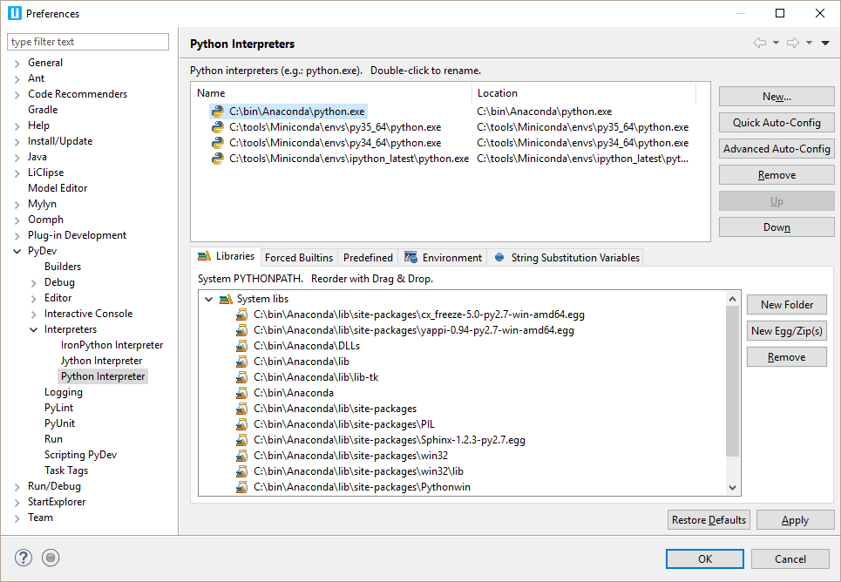
How to check if the information was correctly gotten
The System libs must contain at least the Lib and the Lib/site-packages directory.
The Forced builtin libs must contain the modules built into the interpreter (and others whose
analysis should be done dynamically. See: Forced Builtins).
How to work with virtual environments (virtualenv, conda, etc)
For PyDev, a virtual environment works as any other regular Python executable, so, just click the New... button and select the Python executable in the virtual environment -- just take care to double check the folders which are selected when the virtual environment executable is used to make sure that you leave checked the /Lib folder from the base interpreter if the virtual environment inherits the PYTHONPATH from a base installation).
venv is the recommended way of managing virtual environments starting from Python 3.5. By default, venv will only symlinks to Python interpreter, and this will cause the pip of the created virtual environments in Pydev showing all system installed site-packages. To get it displayed correctly, you will need to append "--copies" to the "python3 -m venv /path/to/venv"
What if it is not correct?
The most common error is having a problem in the environment variables used from the shell that spawned Eclipse, in a way that for some reason when getting the variables of one interpreter, it gathers the info from another interpreter (thus mixing the interpreter and the actual libraries).
Usually running (from the command prompt) the file that gives that info for PyDev can help you discovering the problem in your configuration (interpreterInfo.py):
That file is usually located at: eclipse\plugins\org.python.pydev_$version$\pysrc\interpreterInfo.py, but it can be at other location depending on how you installed it )
In Python: python.exe interpreterInfo.py
In Jython: java.exe -cp c:\path\to\jython.jar org.python.util.jython interpreterInfo.py
In IronPython: ipy.exe interpreterInfo.py
If you're unable to find out what's going on, please open an issue in the tracker (https://www.brainwy.com/tracker/PyDev (giving the output obtained from executing interpreterInfo.py in your machine).
What if I add something new in my System PYTHONPATH after configuring it?
Since PyDev 3.0, such modifications should be automatically detected by PyDev and require no further steps (so, if you pip-installed something or manually added it to a folder which is already in the PYTHONPATH -- such as Lib/site-packages -- just wait a bit and PyDev should start considering it in code-analysis and code-completion).
Libraries
The System libs are the libraries that will be added to the PYTHONPATH of any project that is using this interpreter.
For Python and IronPython, it's composed of folders, zip files and egg files. Note that if dlls should be added to the PYTHONPATH, the folders actually containing those dlls should be added, and they must have the same name to be imported in the code (the case is important). I.e.: if you want to import myDllModule, it must be called myDllModule.dll (note that .pyd and .so extensions are also accepted).
For Jython, it's composed of folders and jars.
Forced Builtins
The Forced builtin libs are the libraries that are built-in the interpreter, such as _builtin_, sha, etc or libraries that should forcefully analyzed through a shell (i.e.: to analyze modules in this list, PyDev will spawn a shell and do a dir() on the module to get the available tokens for completions and code-analysis) – still, sometimes even that is not always possible, in which case, Predefined Completions may be used to let PyDev know about the structure of the code.
For Python, you should have around 50 entries
For Jython around 30 entries.
For IronPython more than 100 entries. All the packages built into .NET should be included here – e.g.: Microsoft, Microsoft.Windows.Themes, System, System.IO, etc.
Additionally, you may add other libraries that you want to treat as builtins, such as os, wxPython, OpenGL, etc. This is very important, because PyDev works on the java side only with static information, but some modules don't have much information when analyzed statically, so, PyDev must create a shell to get information on those. Another important thing is that they must be on your System PYTHONPATH (otherwise, the shell will be unable to get that information).
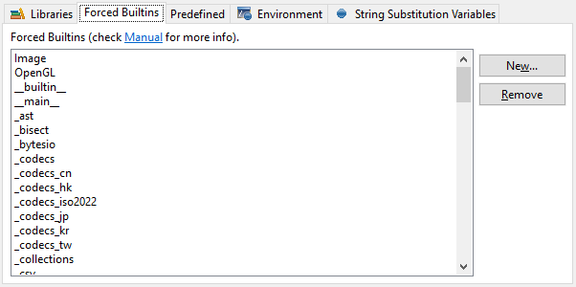
Predefined Completions
Predefined completions are completions acquired from sources that provide only the interfaces for a given Python module (with Python 3.0 syntax).
A predefined completion module may be created by having a module with the extension .pypredef with regular Python 3.0 contents, but with attributes having assigns to its type and methods having as the body a sole return statement – and the docstring may have anything.
Example for a my.source.module (must be declared in a my.source.module.pypredef file):
MyConstantA = int
MyConstantB = int

class MyClass:

instanceAttribute = QObject

def __init__(self, parent=None):
'''

@type parent: QObject
'''

def registerTimer(interval, object):
'''

@type interval: int
@type object: QObject
'''
return int
Note 1: the name of the file is the exact name of the module
Note 2: .pypredef files are not searched in subfolders
Optionally a QScintilla .api file may be added. When this is done, PyDev will try to create .pypredef files from that .api file and will add the folder containing those to the PYTHONPATH. Note that this conversion is still in beta and the file may not be correctly generated, so, keep an eye for errors logged when a code-completion that would use those modules (while it will not fail, those completions won't be shown using the .pypredef files). In those situations, please create a bug-report with the .api file that generated incorrect code.
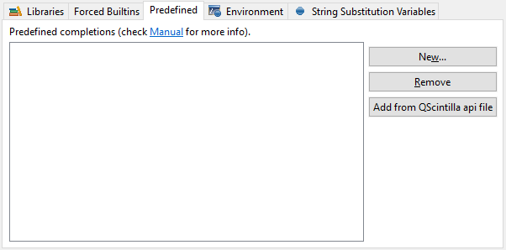
Environment
The variables defined at the environment will be set as environment variables when running a script that uses the given interpreter (note that it can still be overridden in the run configuration)
String substitution variables
Strings defined here may be used in:
- project configuration for source folders and external libraries
- launch configuration for the main module
They can be used in those places in the format: ${DECLARED_VARIABLE}

Creating a Project
Ok, now that your interpreter is configured, it is time to create a project.
Note: if you have existing sources see more details below: Creating a Project from existing sources
After opening Eclipse, go to the menu:
File > New > Project > PyDev > PyDev project. You should see the screen below:
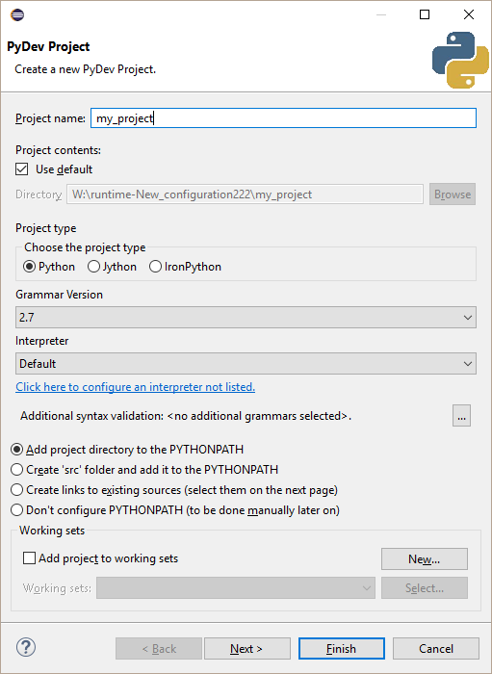
Project name: The name of the project.
Project contents: Where the project should be located in the filesystem (can be pointed to existing sources).
Project type: Defines the kind of the interpreter to be used for that project.
Grammar version: The grammar used for parsing the files in this project. It doesn't have to match the grammar of the actual interpreter selected. This is done so that you can use a newer interpreter while having the grammar you use compatible with an older interpreter (e.g.: using a Python 2.6 interpreter with a Python 2.4 grammar in the project).
Interpreter: Defines which interpreter should be used for code-completion and default run configurations (note that you can still create a run configuration with a different interpreter).
Additional syntax validation: Here you can add additional syntaxes to which the sources of this project should be validated (so, if a project should be Python 2 and Python 3 compatible, you could select the main grammar as Python 3 and an additional syntax validation as Python 2).
PYTHONPATH configuration: It's possible to have the project directory directly be the main PYTHONPATH entry (which is the most common setup), create a src folder and have that folder added to the PYTHONPATH, create links to existing sources or don't configure any folder to be in the PYTHONPATH (in which case it should be manually configured later on).
You may finish in this screen or go to the next, where you will be asked which projects are referenced from this one (or have an additional step to create links to existing sources if you chose such option in the PYTHONPATH configuration).
Referenced projects
The referenced projects are the projects whose source folders are added to the PYTHONPATH for the referrer project.
The next tutorial page enters into more details on project references
Creating a Project from existing sources
If you created the project inside Eclipse, you just have to import the project again (in files > import > general > existing projects into workspace) – it'll look for the existing .project file and will configure it automatically from the existing configuration.
If you have the sources from an existing project that wasn't created in Eclipse, you can either create a new project at that same location (and choose Add project directory to the PYTHONPATH) or create it in a different directory and choose create links to existing sources in the PYTHONPATH configuration in the new project wizard.
See the FAQ for more information.

Here you will learn to further configure your project and add Python information to an already existing project.
The first thing to know about PyDev is that to use it to its full extent, you must have your python modules beneath a source folder (the source folders are the paths that are added to your PYTHONPATH).
You can add a new source folder in the menu: File > new > other > PyDev > source folder or right-click and existing project or folder and select PyDev > Set as Source Folder.
NOTE: You may use PyDev without configuring that, for quick scripts, but some features such as code analysis may not work at all (but you will still have syntax highlighting and the default editor actions).
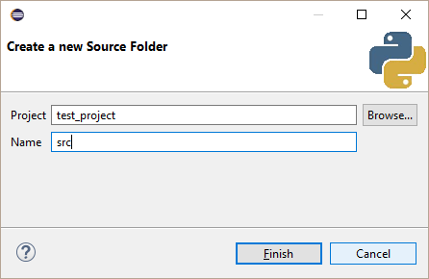
When you add a source folder to an existing project, it will 'automatically' add the PyDev information to it (in Eclipse terms, it will add its nature to it).
You may see which Python information your project has by going to the PyDev Package Explorer, rigth-clicking the project you want info on and selecting 'properties' (or pressing Alt+Enter with the project selected):
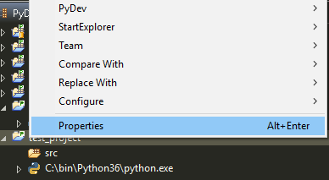
The project properties allow you to see the source folders and the external source folders that will be added to your PYTHONPATH. Note that both the Source Folders and External Libraries can use the information on String Substitution Variables defined in the interpreter or in the actual project.
The external source folders are useful if you have some external library or compiled extension that is used solely for one project, so that you don't have to add it to the system PYTHONPATH, however, the information on such folders works as the system information works, it is gathered once and then 'set in stone', so, if you will change it, it is recommended that you create a project for it and make a project reference to that project.
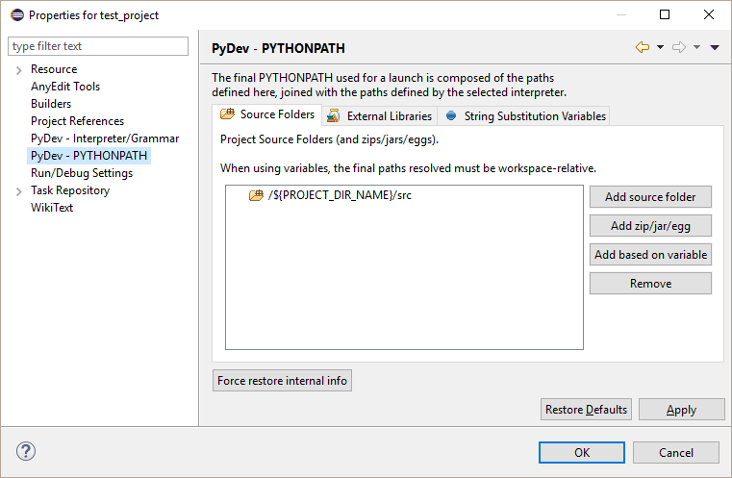
The force restore internal info may be useful if you had an external library that changed and just want to update its information, or you believe that for some reason PyDev did not succeed in synchronizing with the latest code-changes you did.
The String Substitution Variables can be used in conjunction with the source folders, external source folders and run configurations. From the example below, if a reference ${GOOGLE_APP_ENGINE}/lib was present in the external source folders, it'd be resolved to D:/bin/google_app_engine122/lib.
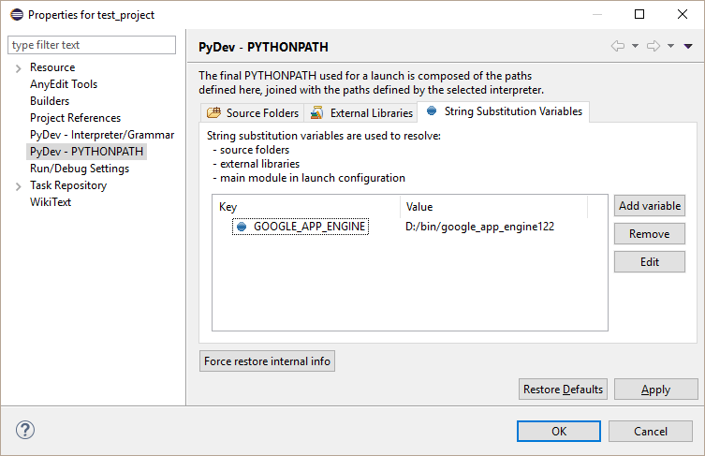
Also, you may change your project type as you wish. E.g.: You can set an existing python project as a jython project in the screen below.
Note that here you can also set a different grammar version (you can have configured an interpreter that uses grammar 2.6 and still use a 2.4 grammar – this is done so that you can use newer interpreter while programming using an older grammar, which is useful on cases where you have to keep backward compatibility).
The selection of the interpreter will define which interpreter will be used to create the default run configurations and the shells for code-completion purposes (to gather the forced builtins).
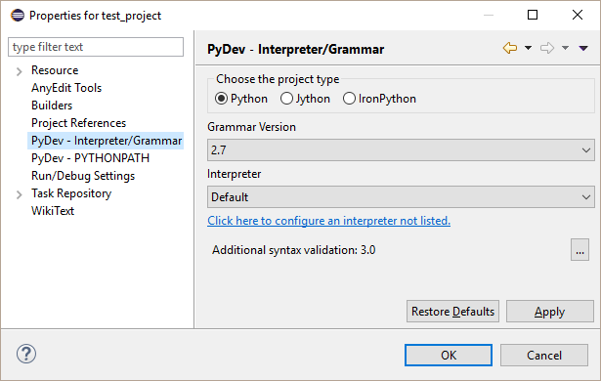
To reference another project, just go to the 'project references' page.
The referenced projects are the projects whose source folders are added to the PYTHONPATH for the referrer project.
This is very important so that code completion and run configurations work correctly.
Note that it'll get the configurations recursively, so, if a project A depends on B, which in turn depends on C, you just have to add a reference from A to B (and C will already be automatically referenced)
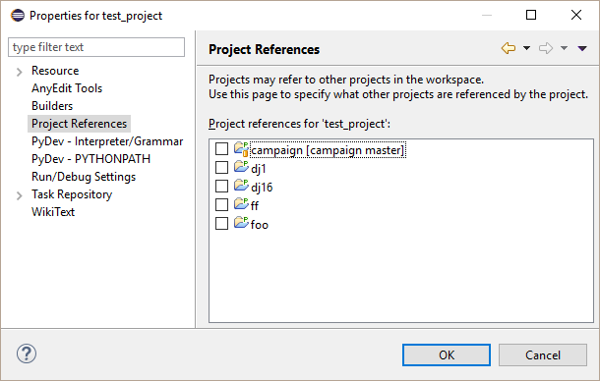
Project reference for Jython users
Jython projects may reference Java (JDT) projects. To create that reference, it's not enough to just add the reference to the JDT project from the PyDev project, the JDT project must be set as a PyDev project and its bin folders must be properly configured as source folders for PyDev.
To do that, right-click the project and select PyDev > Set as PyDev project and add the bin folders as if they were regular PyDev source folders (the ones containing your .class files – the folders containing the .java classes shouldn't be referenced in the PyDev config).
Note: Before version 1.4.8, PyDev did not handle a JDT project which had .py files correctly (even if the folders were properly configured)

Creating our first module (now that the interpreter and the project are already configured).
To make things easier, make sure that you are in the PyDev perspective – it is automatically opened when you create a PyDev project, but just in case, you can open it by going to the menu: Window > Perspective > Open Perspective > Other ... > PyDev, as pointed in the picture below.
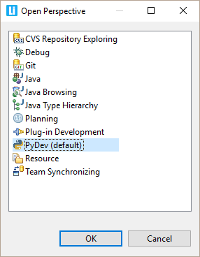
A perspective defines what appears in your window and which actions are enabled... If you want to add something (as a menu or action), you can go to the menu: Window > Perspective > Customize Perspective .... To create our first module, we will use the default PyDev perspective, as it already has the wizard shortcuts pre-defined in the File > New menu
First, we will start creating a new package in a project named 'test' (it was created with the default 'src' folder, and all the code should be put underneath it).
So, let the 'src' folder selected and go to the menu: File > New > PyDev package (or Alt+Shift+N, A) and fill the package name as below (the source folder should be automatically filled)..
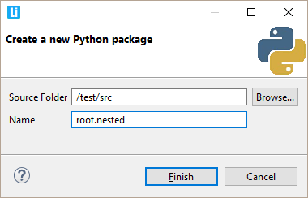
If everything goes ok, the structure below will be created (and the file /root/nested/__init__.py will be opened).
Note: Check to see if the 'P' icon is appearing for your items (as in the picture below) and in the top of your editor after opening it. If it's not appearing, it may be that there's a problem with the file association, so, go to Window > Preferences > General > Editors > File Associations and make sure that the .py files are associated with the Python Editor (note that because of an eclipse bug, if it seems correct, you may have to remove the association and add it again)
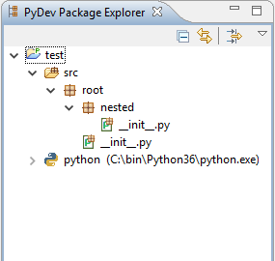
Now, let's create the example module. Select the folder /root/nested and go to the menu: File > New > PyDev module (or Alt+Shift+N, M) and fill the module name as below (again, the other fields should be automatically filled).
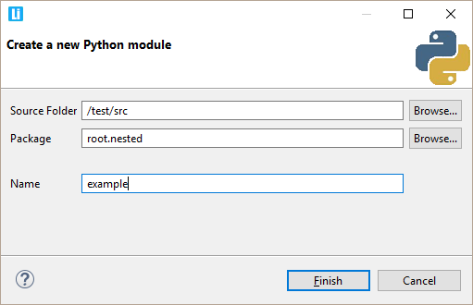
After you press Finish, a new dialog with which module template should be used to create the module will be shown (and the Config available templates... link in the dialog can take you to the place where you can add/remove/edit those - which are the templates under the New Module context.
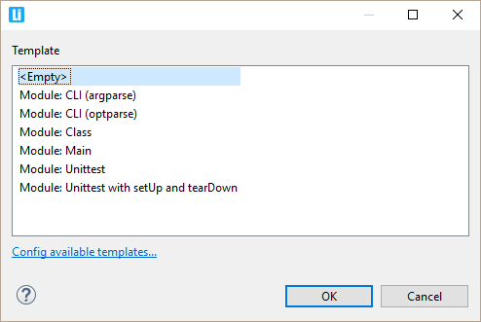
The file /root/nested/example.py should have been created, so, to finish this example, in the empty file, press Ctrl+Space (that's the shortcut for the PyDev code-completion). Once you do that, the 'context-sensitive' completions should appear (as below).
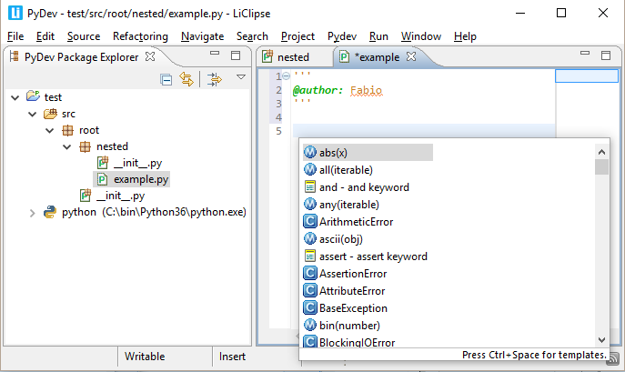
NOTE: If the code-completion does not work, see the FAQ on the topic.
NOTE FOR JYTHON USERS: If you are in jython, the first activation might take a while. This usually happens when jython has to do the processing of new jars. The next time you start it, if it takes the same time, it could be that your jython 'cache-dir' is not writable, so, you can create a script with the code below to see where is the cache dir and check its permissions (or if there is no permission problem, you can try deleting the dir and seeing if it gets correctly recreated in the next jython activation).
Code:
import sys

print(sys.cachedir)

Ok, now that you're already up and running, let's run a program from within Eclipse with PyDev.
For that, we will extend the module we created in the previous chapter with the following program:
if __name__ == '__main__':
print('Hello World')
Then, to run the file you can:
- Use a shortcut: F9 to run the open editor based on the project configuration where the module is contained (or for debug mode Shift+F9).
- Go to the menu: Alt + R + S + The number of the Run you wish (It can be Python, Jython, unit-test, etc).
- Note: if you were using unit-tests, you could use: Ctrl+F9 to run the unit-tests from the module (and even selecting which tests should be run -- and if Shift is pressed it's launched in debug mode).
  - Tip: you may want to pre-select the test to be run in the editor (with Ctrl+Shift+Up or Ctrl+Shift+Down) so that Ctrl+F9 will have that test pre-selected to run.
NOTE:
External files may be launched, but an associated project must be available. So, a file may be dragged from the filesystem into Eclipse and later, with the editor open F9 may be pressed to run the file...
It'll still ask for a project to resolve the PYTHONPATH and interpreter to be used (you can probably just use any project you have that has the interpreter you want to use for the run or create a PyDev project as 'external_projects' and bind those runs to it).
-- The configuration created may be changed later on in the menu: Run > Run Configurations.
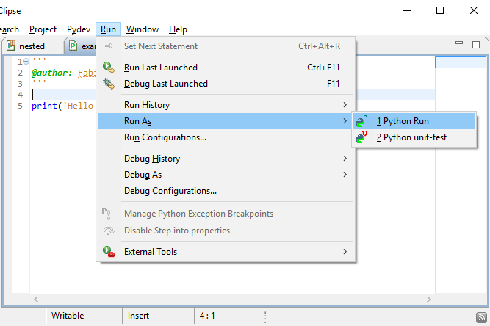
By launching a file, the console should be brough forward with the output of the code (if you had some exception raised, clicking on it would bring you to the code in the stack-trace).
After the first run, using Ctrl+F11, the last file should be re-run. Or, if you type just F11, a debug session is started with your last run.
Note: This behavior changed in Eclipse 3.3 – but it's generally recommended to restore it in the preferences at: Window > Preferences > Run/Debug > Launching and set the Launch Operation to Always launch the previously launched application. This tutorial will always consider this as the default option.
Now, let's go on to starting a debug session. First, you'll need to add a breakpoint in the print('Hello World') line. To do so, go to that line, use Ctrl+F10 and select 'Add breakpoint' (or double-click the left ruler), then use the F11 to re-run the last launch. Doing so, will trigger you to go to the debug perspective. You should say yes to this dialog.
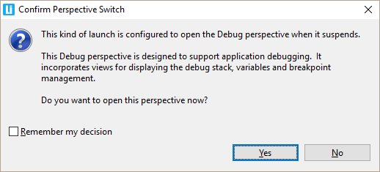
After saying yes, you should be brought to the perspective below.
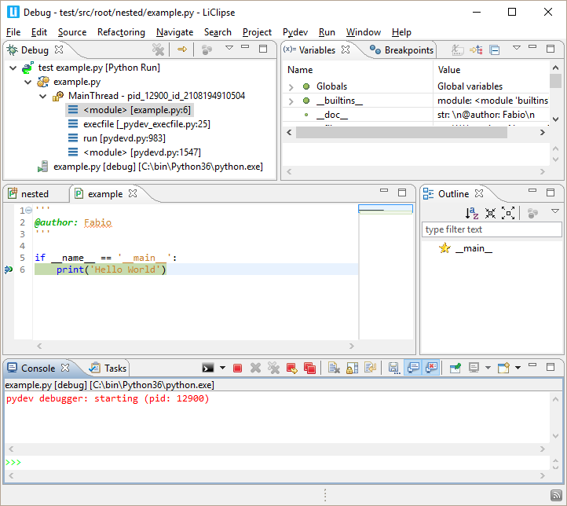
In this perspective, the debug actions are activated and presented to
you, so, you can use:
F5: Step into
F6: Step over
F7: Step return
F8: Resume execution
Ctrl+Shift+B: Toggle Breakpoints
Ctrl+Alt+R: Set Next Statement (so, in the example above, you could set the if __name__ == "__main__" as the next line to be executed).
Use line prefixed with >>> in the console to evaluate expressions.
After the debug session, you can return to the previous perspective by using Ctrl+F8 (this keybinding iterates through the open perspectives)... And while we are at it, Ctrl+F7 iterates through the views and Ctrl+F6 iterates through the editors.
Note: you can also add those actions to other perspectives by customizing the perspective (in Window > Perspective > > Customize Perspective ... > Action Set availability enable the Breakpoints and Debug options)

Configuring Eclipse to suit your needs
Well, Eclipse has lots of things you can configure, and below are some things that really make a difference...

Configuring auto-refresh
Eclipse by default does not refresh on file changes automatically, so, if you make changes outside of the workspace, you will not see the changes until you refresh it (F5 on the navigator). However, you can change the default setting and ask Eclipse to refresh automatically.
To set auto-refresh, go to window > preferences > general > workspace and check the refresh using native hooks or polling and refresh on access check-boxes.
NOTE: not doing so may have some specially strange results with .pyc files not being deleted, as PyDev will only acknowledge that the .pyc file exists on a refresh.
Note: This is automatically done in LiClipse

Set workspace to be utf-8
The default encoding is possibly not utf-8 (depending on your OS, it can be cp1252, ascii, etc), so, the suggestion is setting the default encoding to utf-8 in window > preferences > general > workspace > text file encoding (and you may also want to change the new line delimiter to be unix style on Mac and Windows in that same page).
Note: This is automatically done in LiClipse

One of the main advantages of using an IDE is being able to navigate through your code in a really fast way, so, let's see how to find what you want when coding in PyDev...
1. Open file in your workspace

The simplest way is searching for any resource for any project you have available (this is actually provided by Eclipse itself). So, if you know the file name (or at least part of it), use Ctrl+Shift+R and filter using the Open Resource dialog:
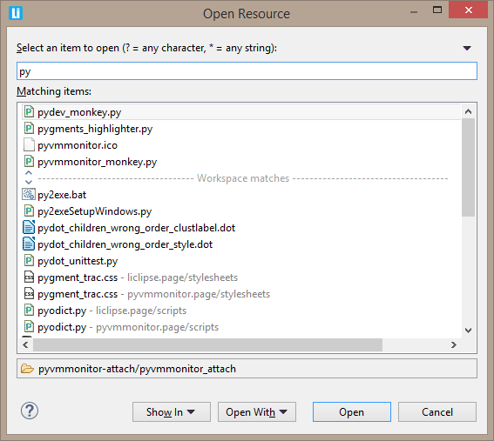

2. Go To Python Token (package, module, class, method or attribute in project or interpreter)

Another way of getting to what you want is using the PyDev Globals Browser (using Ctrl+Shift+T).
This is actually what I use most as a single place can be used to filter for package names, classes, methods and attributes inside your own projects or any other package in Python itself. Also, it allows for advanced filtering, so, you can search for tokens only inside a package (i.e.: dj.tz filters for any 'tz' token inside django in the example below).
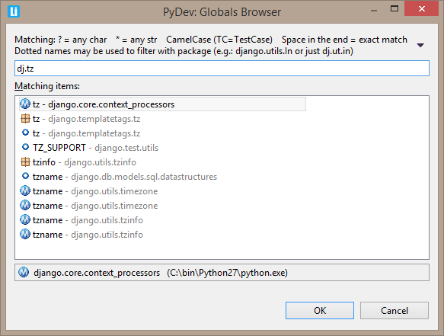

3. Quick Outline (current editor)

Ctrl+O will show a Quick Outline which shows the structure of your current file. Pressing Ctrl+O one more time in this dialog will also show the structure of superclasses in the hierarchy (you can see that in the example below __setitem__ appears twice, once for the method in this class and another one for the superclass).
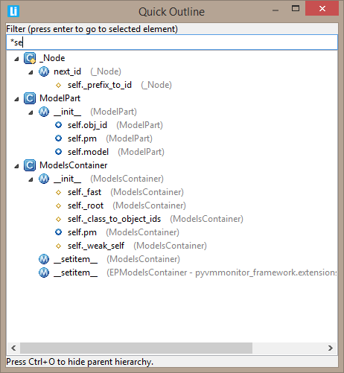

4. Selection History

Go back and forward in your selection: Alt+Left goes to the place you were before and Alt+Right to the place you just went from... this allows you to easily go navigate through your recent places.
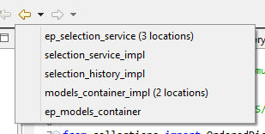

5. Open files
To filter through the open files you can use Ctrl+E: a dropdown will appear and from there you can filter through its name and you can close existing editors using Del from that dropdown too.
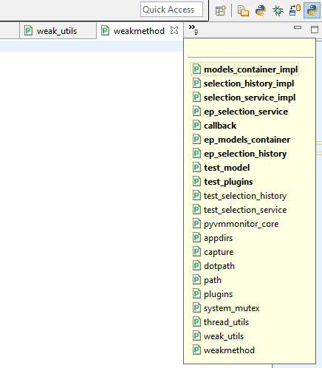

6. Go to previous next token (class or method)
Ctrl+Shift+Up and Ctrl+Shift+Down allows you to quickly navigate from your current position to the previous or next method (selecting the full method/class name).
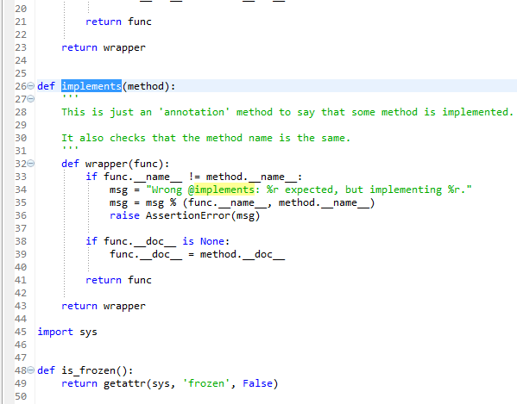

7. Navigate through occurrences and errors in the file
Ctrl+. (i.e.: Ctrl + Dot) allows navigating through occurrences and errors found in the file, so, in the case below we'll navigate through the occurrences of 'func'.
Note: An alternative way of doing the same thing is using Ctrl+2, R (which can be used to do a rename of the tokens) and cycle using Tab.
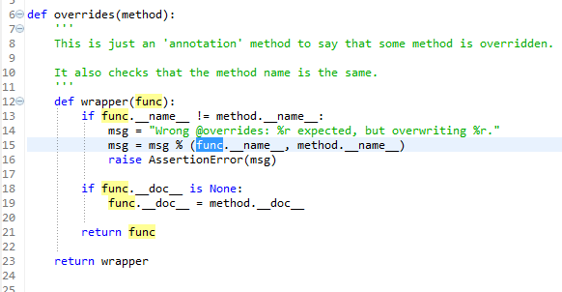

8. Go to some view/menu/action/preference

This is an Eclipse standard mechanism: using Ctrl+3 allows you to navigate to any part of the IDE.
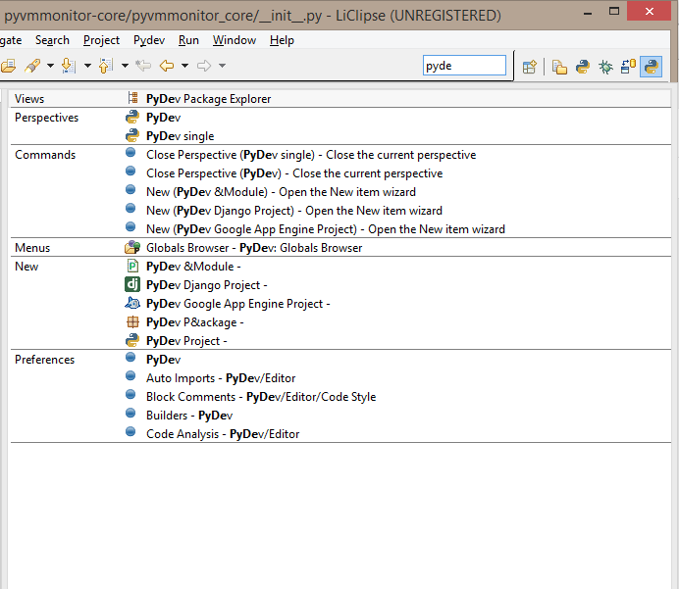

9. References
Ctrl+Shift+G will make a search showing all the references to the token under the cursor (and the search view where results are shown can be navigated with Ctrl+Dot).
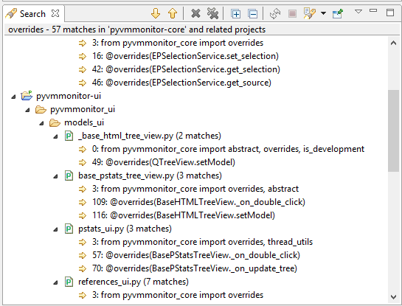

10. Go to definition
Just press F3 or Ctrl+Click some available token and go directly to the selected place.
11. Hierarchy View

Using F4 shows a hierarchy view where you can see the structure of your classes.
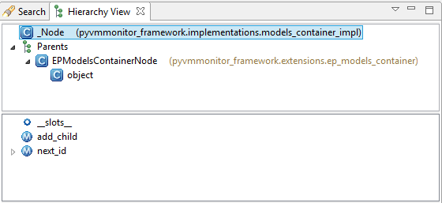

12. Show In
Alt+Shift+W allows you to see the current file in a given place (such as the PyDev Package Explorer or the System Explorer from your OS) or your current class/method in the Outline View.
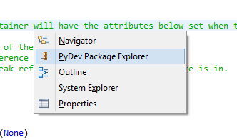

Others

The ones below are available in standard Eclipse and you should also definitely know about it :)
Ctrl+L allows you to navigate to a given line in your current editor.
Ctrl+Q goes to the place where the last edition was made.
Ctrl+F6 navigates through the opened editors. In LiClipse Ctrl+Tab is also bound to it by default-- and I suggest you also add this binding if you aren't using LiClipse :)
Ctrl+F7 navigates through opened views (i.e.: Package Explorer, Outline, etc.)
Ctrl+F8 navigates through opened perspectives (i.e.: PyDev perspective, Debug perspective, etc).
Ctrl+F10 opens the menu for the current view (so you can select filters in the Package Explorer, etc.)
F12 focuses the editor (so, you can go from any view to the editor)
Ctrl+H Opens the search dialog so you can do text searches
Ctrl+Shift+L twice goes to the keybindings preferences

Now you can enjoy going really fast to any place you wish inside PyDev!

There are some simple things which everyone should know when writing code on PyDev:
1. Want to write a new line? Use Shift+Enter: This is what should be almost always used in PyDev instead of the plain enter to enter a new line.
How it works: It'll emulate moving to the end of the line and pressing enter there (so, it can be used from any position in the line).
Tip: It can be used when there's a completion to avoid applying it while going to the next line (as Enter is also used to apply a completion if you don't use Shift+Enter you have to press ESC before to avoid applying it if you use a plain Enter).
2. Want to copy or move some lines? Ctrl+Alt+Up will copy the lines up and Ctrl+Alt+Down will copy them down and then Alt+Up or Alt+Down can be used to move them up or down (so, it's a line-oriented copy/paste which is really handy).
3. Is there a string or comment which is too big and you want to wrap it? Use Ctrl+2, W and it'll wrap it for you (using the number of columns assigned in the print margin preferences).
4. Want to create a docstring for the parameters of a method? Ctrl+1 -> Make Docstring (in a line with the method declaration).
5. Assign parameters to variables? Ctrl+1 -> Assign parameters to attributes (in a line with the method declaration in a class). Alternatively use Ctrl+2, A.
6. Want to select the current word? Shift+Alt+Up will select the current word for you (and if you keep using Shift+Alt+Up it'll then select the enclosing context and Shift+Alt+Down will deselect it again).
7. Rectangular selection: Shift+Alt+A.
8. Want to rename a local token? To do that use Ctrl+2, R (note that for renaming a token in multiple modules you'd use Shift+Alt+R or a package/module in the PyDev Package Explorer would be renamed with F2).
9. To rename something that's not a token (such as a comma) -- if you're in LiClipse (which adds this feature) -- you can do Ctrl+K (or Ctrl+Shift+K to go backwards) multiple times to mark the places you want to rename and then go on to rename it (as a note, Ctrl+Alt+K will unlink one of the occurrences). This can also be used for a substring -- or any character combination for that matter.
10. Do you have some code with multiple tokens that are not found and need to be imported? Ctrl+Shift+O can be used to resolve the multiple missing tokens. Alternatively you could also use Ctrl+1 on a line with a missing import to get the suggestion to add it (if it wasn't already added in a code-completion which added it for you automatically).
11. Like TDD coding? i.e.: write the test first and do the code later. If so, you can usually write the test and use Ctrl+1 to provide a suggestion to create the missing method, module or attribute.
12. PyDev doesn't automatically re-analyze dependent modules when one module changes, so, I've seen people just add some space and save the file again just to force a new code analysis... while this works, there's a specific keybinding: Ctrl+2, C which will force a code-analysis in the current module.
13. When there are many contiguous lines commented and you want to uncomment them, do you see yourself selecting all those lines to uncomment it? Did you know that Ctrl+5 does that promptly for you from any line of that block?
14. Just edited something but don't remember where it was? Ctrl+Q can be used to go to the last place you edited some code.
15. Do you have some code you just copied from somewhere and want to create a module with it? Go to the PyDev package explorer and just paste the code (Ctrl+V) there to create a new module with those contents.
16. Do you have some method call or variable that you want to add to another local variable or field? Use Ctrl+1 (on a line that still doesn't have an assign) and choose assign to local or assign to field.
Besides those tips, print the bindings from: Keybindings quick-reference and leave it by your side until you don't master them :)

